Project Design Phase-II Technology Stack (Architecture & Stack)

|  |  |
| --- | --- |
| Date | 17 November 2023 |
| Team ID | Team-591754 |
| Project Name | Predicting Mental Health Illness of Working Professionals |
| Maximum Marks | 4 Marks |

# Technical Architecture:

The Deliverable shall include the architectural diagram as below and the information as per the table1 & table

Guidelines:

1. **Ethical Data Handling**: Prioritize privacy and ethical considerations, obtaining informed consent and anonymizing data to protect participants.

****2 .Holistic Data Collection:**** Gather diverse data, including work-related and personal factors, employing surveys and objective metrics comprehensively assess contributors to mental health.

3.**Appropriate Modeling**: Choose suitable machine learning models and emphasize feature selection to ensure accurate predictions, considering decision trees, support vector machines, or neural networks.

4.**Validation and Interpretability**: Use robust validation techniques, like cross-validation, and prioritize model interpretability to ensure generalizability and actionable insights.

5.**Collaboration with Experts**: Collaborate with mental health professionals to validate the approach, refine the model, and establish responsible usage guidelines aligned with ethical considerations. .

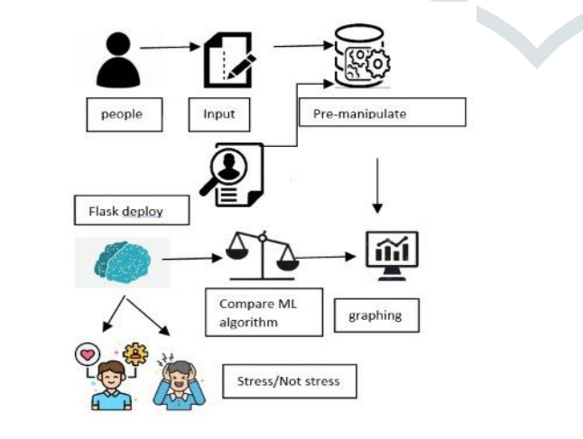

# Table-1 : Components & Technologies:

|  |  |  |  |
| --- | --- | --- | --- |
| **S.No** | **Component** | **Description** | **Technology** |
| 1. | User Interface | user interacts with application with Web UI | HTML, CSS ,Flask |
| 2. | Application Logic-1 | Logic for a process in the application | Python |
| 3. | Database | Data Type, Configurations etc. | MySQL, NoSQL, etc. |
| 4. | File Storage | File storage requirements | Local Filesystem & Storage |
| 5. | Machine Learning Model | Purpose of Machine Learning Model | Predictive Model, etc. |
| 6. | Infrastructure (Server / Cloud) | Application Deployment on Local System Configuration : | Local |